

|  |  |
| --- | --- |
| COURSE NAME: | FINANCE & ACCOUNTING WITH ZOHO BOOKS |
| PROJECT TITLE: | PREPARATION AND MAINTENANCEOF ZOHO BOOKS FOR FRESH BITES CATERING |
| PROJECT SUBMITTED TO: | SMART INTERNZ |
| YEAR: | 2023-2024 |
| DEPARTMENT: | COMMERCE |
| SEMESTER | V |
| TEAM ID: | NM2023TMID10381 |
| MEMBERS OF THE GROUP: | REGISTER NO STUTENT NAME  13211510017 C.T.KRITTIKA  13211510015 S.KEETHANA  13211510014 C.KASTHURI  13211510016 N.KEYSAR JAHAN |
| GUIDED BY: | MRS M PRIYANKA B.COM.,M.COM.,M.PHIL,  MS S GOWSALYA B.COM[CA].,M.COM.,M.PHIL |
| SPOC NAME: | Ms. K. Elizabeth, M.Sc., M.Phil., B.Ed., Assistant Professor |

**INDEX**

|  |  |
| --- | --- |
| **PARTICULAR** | **PAGE NUMBER** |
| **INTRODUCTION** | **3** |
| **FEATURE** | **4** |
| **ADVANTAGE** | **5** |
| **DISADVANTAGE** | **6** |
| **EMPATHY** | **7** |
| **BRIANSTORMING** | **8** |
| **RESULT** | **9** |
| **CONCLUSION** | **11** |

**PREPARATION AND MAINTENANCE OF ZOHO BOOKS FOR FRESH BITES CATERING**

**INTRODUCTION:**

Zoho Books is a cloud-based accounting software solution tailored for small and medium-sized businesses, offering comprehensive tools for efficient financial management. With its user-friendly interface and robust features, Zoho Books simplifies various accounting tasks, including invoicing, expense tracking, bank reconciliation, and financial reporting. Designed to streamline financial operations, Zoho Books enables businesses to maintain accurate records, manage cash flow, and make informed decisions. Through its intuitive dashboard, customizable templates, and seamless integrations, Zoho Books serves as a reliable and versatile platform for businesses to handle their accounting needs effectively and enhance overall financial transparency and control.

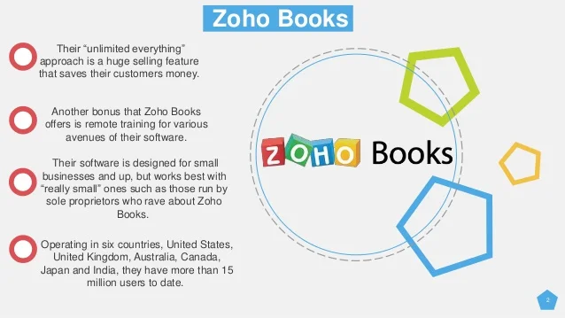

**FEATURE:**

* **Expense Tracking**: Record and categorize business expenses, track receipts, and manage reimbursements to maintain a clear overview of expenditure.
* **Bank Reconciliation**: Seamlessly match transactions, monitor cash flow, and reconcile bank statements to ensure accurate financial records.
* **Financial Reporting**: Generate insightful reports, including profit and loss statements, balance sheets, and cash flow statements, to gain valuable insights into business performance.
* **Inventory Management**: Track stock levels, manage orders, and handle stock adjustments to streamline inventory operations and improve inventory control.
* **Time Tracking**: Monitor billable hours, track project timelines, and manage timesheets to accurately bill clients and analyze project profitability.
* **Multi-currency Support**: Conduct business globally with support for multiple currencies, enabling seamless transactions and financial management across various international markets.
* **Automation and Customization**: Automate repetitive tasks, customize workflows, and set up personalized rules to streamline processes and increase overall efficiency.

These features collectively contribute to Zoho Books' ability to facilitate effective financial management, empower businesses with valuable insights, and optimize overall accounting operation.

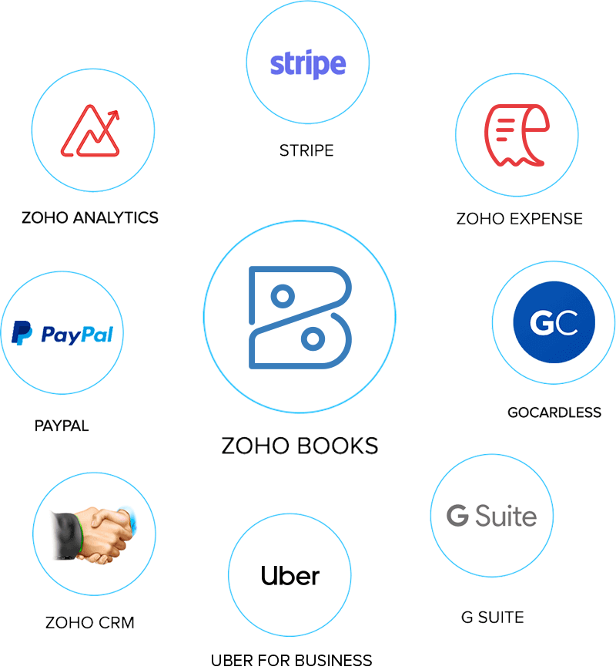

**ADVANTAGE :**

* **User-Friendly Interface**: Zoho Books provides an intuitive and easy-to-navigate interface, making it accessible for users with varying levels of accounting expertise.
* **Comprehensive Functionality**: The platform offers a comprehensive suite of accounting tools, including invoicing, expense tracking, inventory management, and financial reporting, consolidating essential financial operations in one centralized system.
* **Scalability and Flexibility**: Zoho Books caters to the needs of small and medium-sized businesses, allowing for scalability as businesses grow and expand their operations.
* **Affordability**: With various pricing plans available, including options for businesses of different sizes, Zoho Books offers an affordable solution for companies looking to streamline their accounting processes without incurring significant costs.
* **Integration Capabilities**: Zoho Books integrates seamlessly with other Zoho applications and third-party software, facilitating smooth data exchange and enhancing overall workflow efficiency.
* **Security and Data Protection**: The platform prioritizes data security, offering robust encryption and security measures to ensure the confidentiality and protection of sensitive financial information.
* **Customer Support**: Zoho Books provides reliable customer support through various channels, including documentation, tutorials, and responsive customer service, assisting users in resolving issues and maximizing the platform's capabilities.
* By leveraging these advantages, Zoho Books enables businesses to manage their financial operations effectively, make informed decisions, and maintain accurate and transparent financial records, contributing to overall business growth and sustainability.

**DISADVANTAGE :**

* **Learning Curve**: Users with limited accounting knowledge may require time to familiarize themselves with the platform, potentially leading to a learning curve before fully optimizing its capabilities.
* **Limited Customization in Lower Tiers**: Some users might find that the lower-priced plans offer limited customization options compared to higher-priced plans, potentially restricting certain functionalities and customization capabilities.
* **Complexity for Advanced Accounting Needs**: Businesses with complex accounting requirements might find Zoho Books lacking some advanced features available in more specialized accounting software, which could limit its suitability for certain industries or complex financial operations.
* **Integration Limitations**: While Zoho Books integrates with a range of third-party applications, it might have limitations in terms of integrating with specific niche or industry-specific software, potentially affecting workflow efficiency for some businesses with unique software requirements.
* **Customer Support Challenges**: Some users might encounter challenges with customer support, including delayed response times or difficulty in resolving complex issues promptly, which could impact the overall user experience and troubleshooting process.

It's important for businesses to consider these factors when evaluating whether Zoho Books aligns with their specific accounting needs and operational requirements. Understanding these potential drawbacks can help businesses make informed decisions when selecting an accounting software solution.

**EMPATHY MAP :**

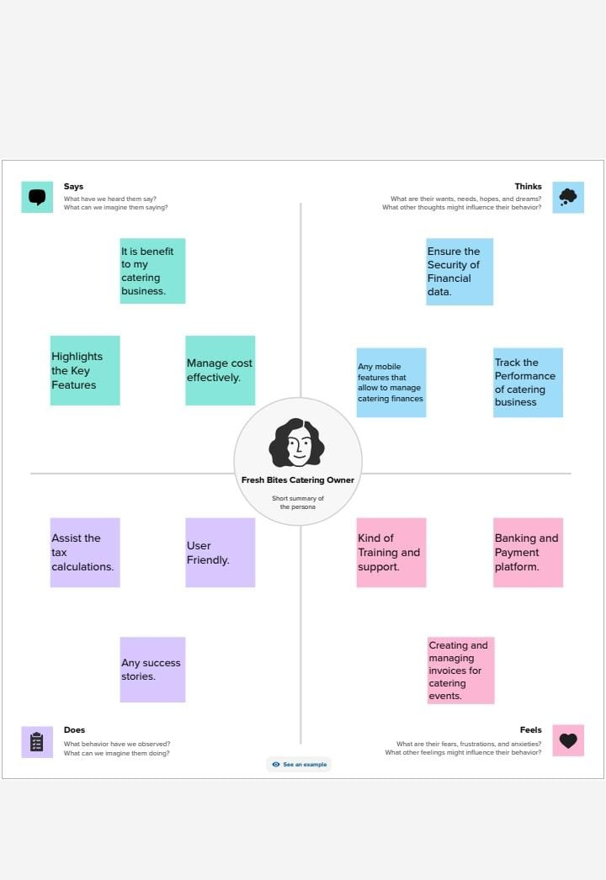

**BRAINSTORMING :**

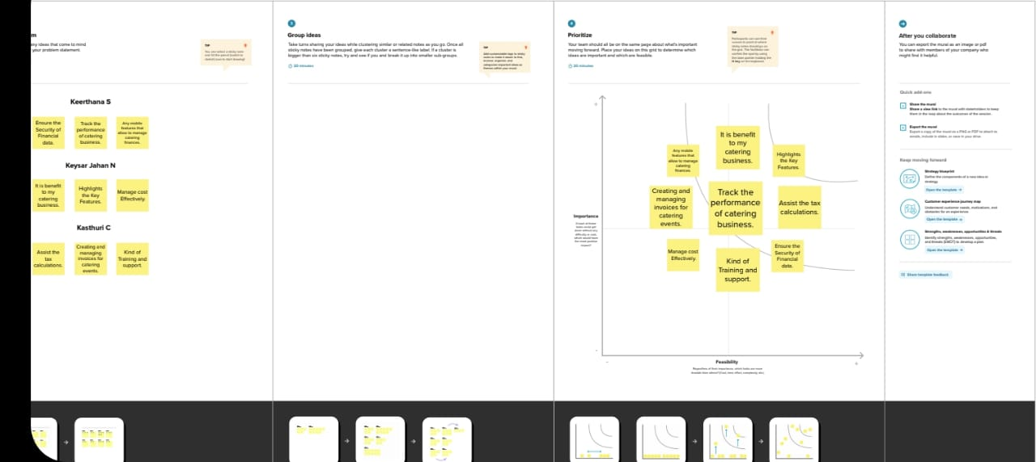

Using the empathy map and brainstorming session, the financial management software can be tailored to address the specific needs and pain points of small business owners, offering a more intuitive and efficient solution for managing their financial operations.

**RESULT:**

**PROFIT & LOSS ACCOUNT :**

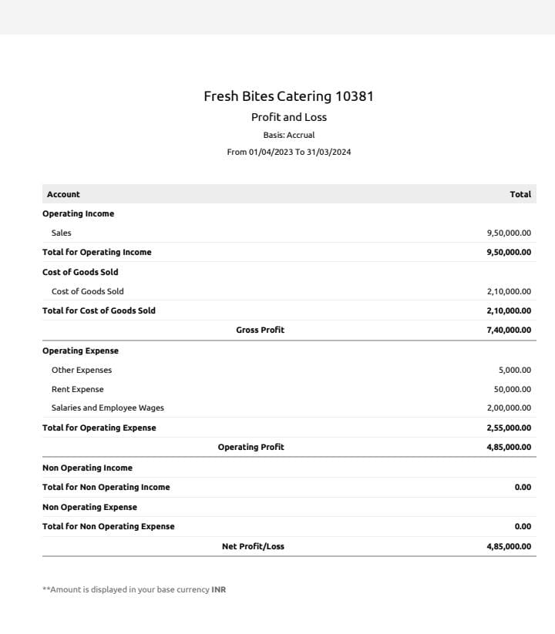

**BALANCE SHEET:**

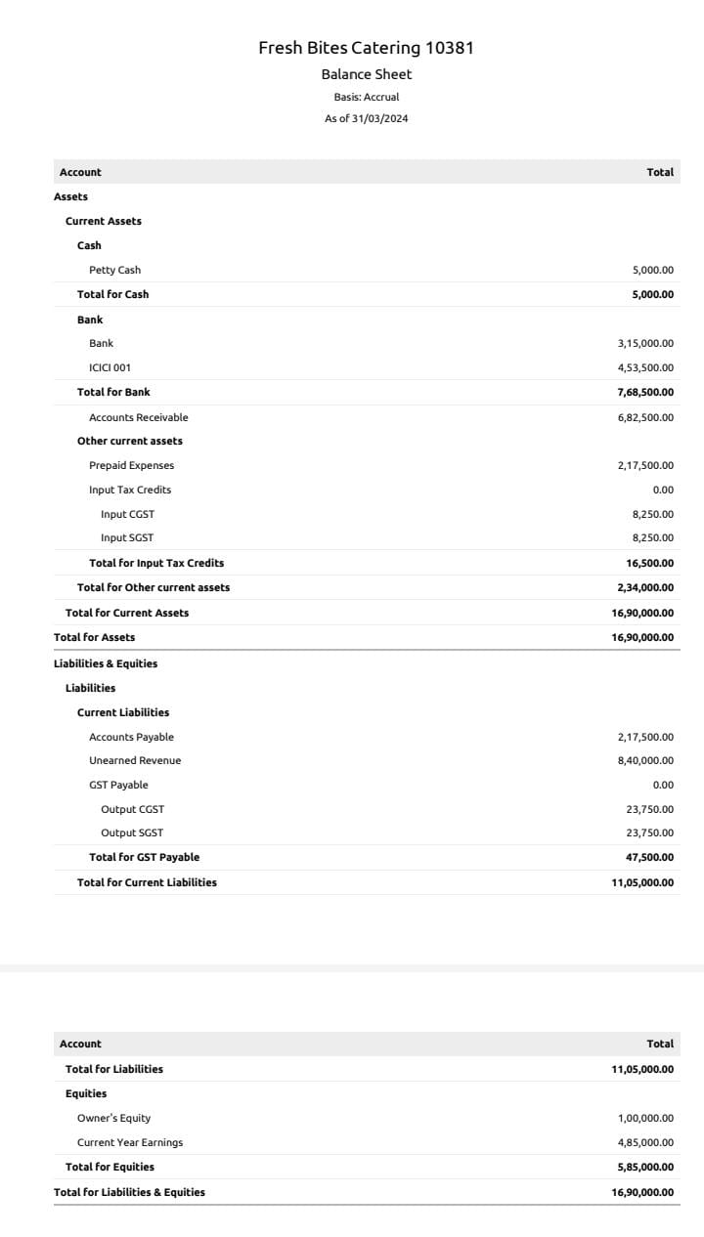

**CONCLUSION:**

Zoho Books enables businesses to adapt and grow, while its seamless integration with other Zoho applications and third-party tools ensures smooth data synchronization and workflow efficiency. Despite potential limitations such as a learning curve for new users and certain constraints for advanced accounting needs, Zoho Books remains a valuable asset for businesses seeking to optimize their financial management processes and establish a strong foundation for sustainable growth and success.